**Name:** Saad Ahmad

**Enrollment:** 01-134222-130

Lab – 01

# Introduction to Tool and Database, Different Data types used in Oracle

**Objective:**

* Students will get familiar with the tool and learn How to interact with oracle using sql plus.

# Oracle9i Features

Oracle offers a comprehensive high-performance infrastructure for e-business. It is called Oracle9i. Oracle9i includes everything needed to develop, deploy, and manage Internet applications.

Benefits include:

* Scalability from departments to enterprise e-business sites
* Robust reliable, available, secure architecture
* One development model, easy deployment options
* Leverage an organization’s current skillset throughout the Oracle platform (including SQL, PL/SQL, Java, and XML)
* One management interface for all applications
* Industry standard technologies, no proprietary lock-in

# Oracle9i Database

Oracle9i Database manages all your data. This is not just the object relational data that you expect an enterprise database to manage. It can also be unstructured data like:

* Spreadsheets
* Word documents
* Powerpoint presentations
* XML
* Multimedia data types like MP3, graphics, video, and more

The data does not even have to be in the database. Oracle9i Database has services through which you can store metadata about information stored in file systems. You can use the database server to manage and serve information wherever it is located.

# System Development Life Cycle

From concept to production, you can develop a database by using the system development life cycle, which contains multiple stages of development. This top-down, systematic approach to database development transforms business information requirements into an operational database.

# Strategy and Analysis

* Study and analyze the business requirements. Interview users and managers to identify the information requirements. Incorporate the enterprise and application mission statements as well as any future system specifications.
* Build models of the system. Transfer the business narrative into a graphical representation of business information needs and rules. Confirm and refine the model with the analysts and experts.

# Design

Design the database based on the model developed in the strategy and analysis phase.

# Build and Document

* Build the prototype system. Write and execute the commands to create the tables and supporting objects for the database.
* Develop user documentation, Help text, and operations manuals to support the use and operation of the system.

# Transition

Refine the prototype. Move an application into production with user acceptance testing, conversion of existing data, and parallel operations. Make any modifications required.

# Production

Roll out the system to the users. Operate the production system. Monitor its performance, and enhance and refine the system. Note: The various phases of the system development life cycle can be carried out iteratively. This course focuses on the build phase of the system development life cycle.

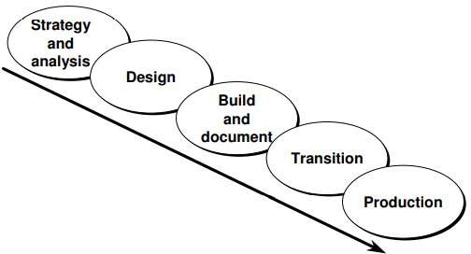

# DATA TYPES:

VARCHAR2 (size)

Variable length character string having max. Length of size CHAR (size)

Fixed length character string with number of bytes equal to size NUMBER (p,s)

Number having a precision p and s digits to the right of the decimal. If you leave off p and s (e.g., NUMBER), then it is a floating point number.

LONG DATE

Character data of variable length up to 2 gigabytes (cannot be a key) A date field

RAW (size)

Raw binary data of length size. Max. size is 255 bytes LONG RAW

Raw binary data up to 2 gigabytes (cannot be a key)

# SQL Table

The database table columns (called also table fields) have their own unique names and have a pre-defined

data types. Table columns can have various attributes defining the column functionality (the column is a primary key, there is an index defined on the column, the column has certain default value, etc.).

While table columns describe the data types, the table rows contain the actual data for the columns.

Here is an example of a simple database table, containing customers’ data. The first row, listed in bold, contains the names of the table columns:

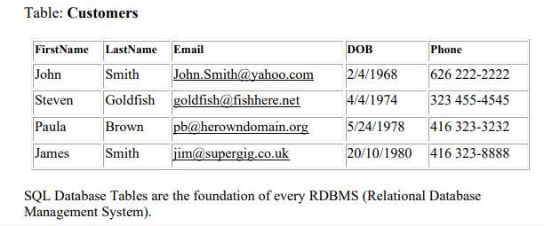

# Storing Information

Every organization has some information needs. A library keeps a list of members, books, due dates, and fines. A company needs to save information about employees, departments, and salaries. These pieces of information are called data.

Organizations can store data on various media and in different formats—for example, a hard-copy document in a filing cabinet or data stored in electronic spreadsheets or in databases. A database is an organized collection of information.

To manage databases, you need database management systems (DBMS). A DBMS is a program that stores, retrieves, and modifies data in the database on request. There are four main types of databases: hierarchical, network, relational, and more recently object relational.

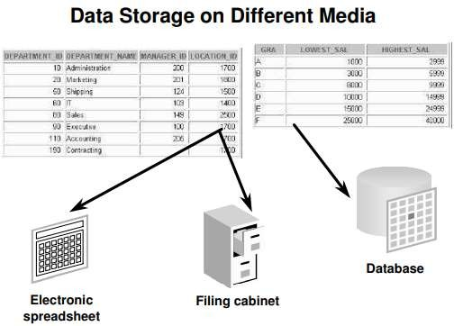

# Relational Model

* Dr. E.F. Codd proposed the relational model for database systems in 1970.
* It is the basis for the relational database management system.
* The relational model consists of the following:
  + Collection of objects or relations
  + Set of operators to act on the relations
  + Data integrity for accuracy and consistency

# Definition of a Relational Database

A relational database uses relations or two-dimensional tables to store information.

For example, you might want to store information about all the employees in your company. In a relational database, you create several tables to store different pieces of information about your employees, such as an employee table, a department table, and a salary table.

# Data Models

Models are a cornerstone of design. Engineers build a model of a car to work out any details before putting it into production. In the same manner, system designers develop models to explore ideas and improve the understanding of the database design.

# Purpose of Models

Models help communicate the concepts in people’s minds. They can be used to do the following:

* Communicate
* Categorize
* Describe
* Specify
* Investigate
* Evolve
* Analyze
* Imitate

The objective is to produce a model that fits a multitude of these uses, can be understood by an end user, and contains sufficient detail for a developer to build a database system.

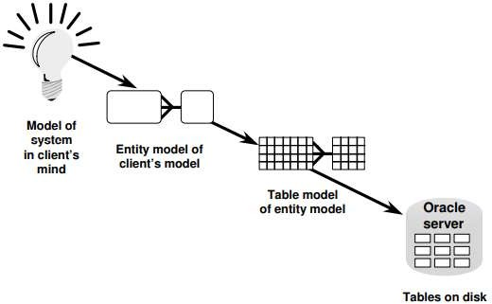

# Relating Multiple Tables

* Each row of data in a table is uniquely identified by a primary key (PK).
* 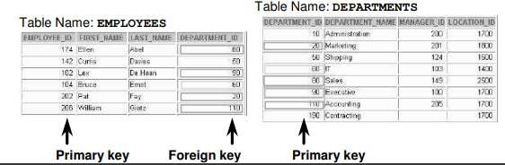You can logically relate data from multiple tables using foreign keys (FK).

# Properties of a Relational Database

In a relational database, you do not specify the access route to the tables, and you do not need to know how the data is arranged physically.

To access the database, you execute a structured query language (SQL) statement, which is the American National Standards Institute (ANSI) standard language for operating relational databases. The language contains a large set of operators for partitioning and combining relations. The database can be modified by using SQL statements.

# Structured Query Language

Using SQL, you can communicate with the Oracle server. SQL has the following advantages:

* Efficient
* Easy to learn and use
* Functionally complete (with SQL, you can define, retrieve, and manipulate data in the tables)

# SQL Statements

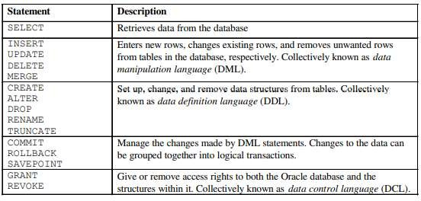

**Code:**

CREATE TABLE Employees (

ID int,

Name varchar(255),

City varchar(255),

Country varchar(255)

);

INSERT INTO Employees(ID, Name, City, Country)

VALUES ('130', 'Saad', 'Islamabad', 'Pakistan');

INSERT INTO Employees(ID, Name, City, Country)

VALUES ('120', 'Ahmed', 'Islamabad', 'Pakistan');

INSERT INTO Employees(ID, Name, City, Country)

VALUES ('110', 'Haris', 'Islamabad','Pakistan');

SELECT * FROM Employees;

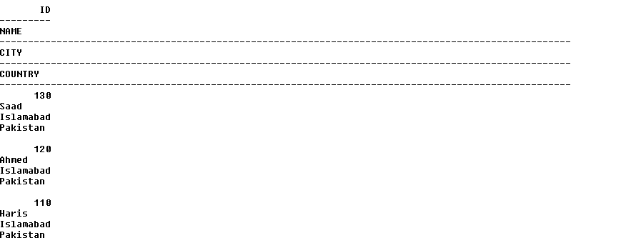

UPDATE EMPLOYEES

SET Name='Haris'

WHERE ID='120';

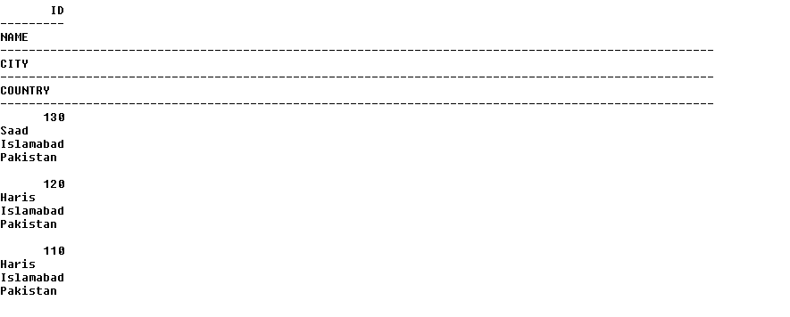

SELECT Name FROM Employees;

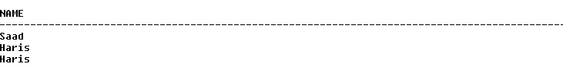

SELECT ID,Name FROM Employees;

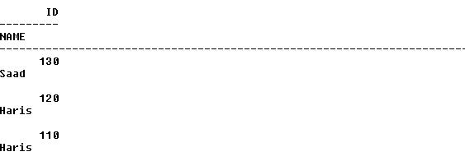

**Output:**

